Creating an Accessible Microsoft Excel Spreadsheet

Table of Contents
HYPERLINK 3
IMAGE 4
TABLES 5
COLOR CONTRAST 6
Sheet Tab(s) 10
ACCESSIBILITY CHECKER 10

Creating an Accessible Microsoft Excel Spreadsheet
Below is the important aspects that you need to follow in order to make your Word Doc accessible to all users as well as complies with section 508.

- Hyperlink
- Image
- Table(s)
- Color contrast
- Sheet tab(s)
- Accessibility checker

HYPERLINK
Hyperlinks are not always human-readable or screen-reader friendly. It is better to use human-readable text instead of lengthy or unreadable hyperlinks.

How to make hyperlink accessible in the MS Excel Spreadsheet?

- Select the hyperlink.
- Right click on the hyper link and select “Hyperlink”.
- Then, select “Edit Hyperlink”.
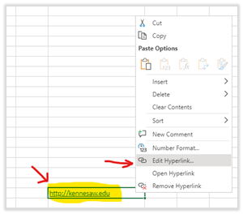

- Once the hyperlink dialog appears, delete the URL at the “Text to Display” box and type the descriptive text and then hit “OK”.
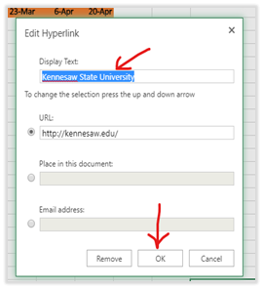

IMAGE
Alternative text (alt text) provides screen reader software users with access to all of the non-text information.

How to make an image accessible in the MS Excel Spreadsheet?

- Click on the image.
- Right click and select “Edit Alt Text”.
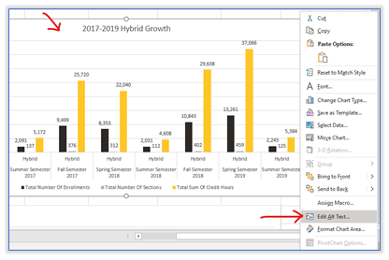

- The “Alt Text” dialog box will show up on the right pane. Type in the description of the image into the given box.

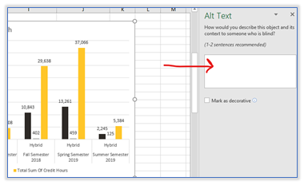

TABLES
Screen readers keep track of their location in a table by counting table cells. If a table is nested within another table or if a cell is merged or split, the screen reader loses count and can’t provide helpful information about the table after that point. Blank cells in a table could also mislead someone using a screen reader into think that there is nothing more on the table.

Be sure to create a header row to your table.

How to make accessible tables in the MS Excel Spreadsheet?

To specify a header row in a new block of cells you are making as a table, complete the following steps:
- Select the cells you want to include in the table.
- On the “Insert” tab, select “Table”.
- In the “Create Table” dialog, select the “My table has headers” check box.
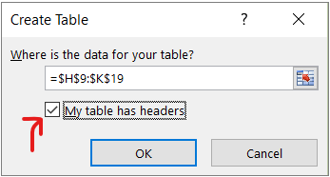
- Select “OK”. Excel creates a header row with the default names “Column1”, “Column2”, and so on.
- Type new, descriptive names for each column in the table.
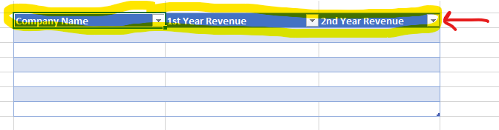

COLOR CONTRAST
Color contrast is crucial for users with visual disabilities. To make content accessible for them, content creator needs to take the ratio of the foreground and the background color into consideration.
According to WACG 2.0, the standard ratio of the foreground and background color should be at least 4.5:1
How to make sure that the color contrast meets the minimum accessibility standard?
The easiest way to measure the color contrast ratio is to use the Colour Contrast Analyser (CCA). This CCA will calculate the contrast ratio for you as well as give you the WCAG 2.1 results.

- Go to Colour Contrast Analyser website and click on “Download for Windows/ macO.”
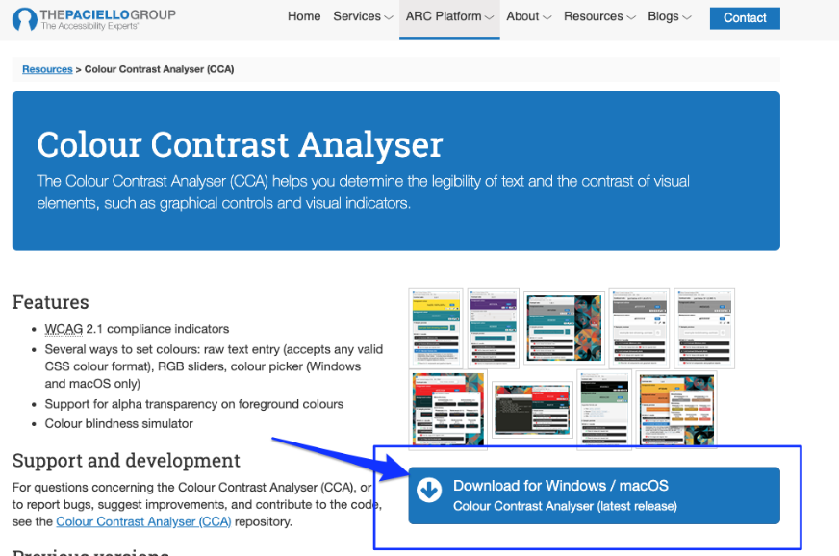
- Scroll down to the Assets section.
If you are a Mac user, click on “CCA-1.2.1.dmg” to download.
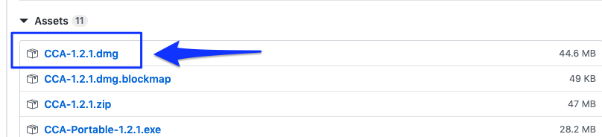
If you are a Windows user, click “CCA-Setup-1.2.1.exe” to download.
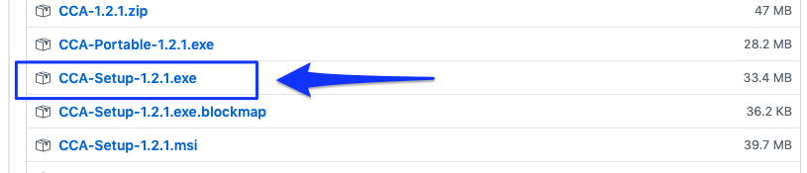
- Double click on the downloaded file and install it to your computer.
- Once you have installed it, the Colour Contrast Analyser (CCA) window will show up.
- Make sure that the “Hex” color code option is selected. Then, click on the color picker icon at the Foreground color section.
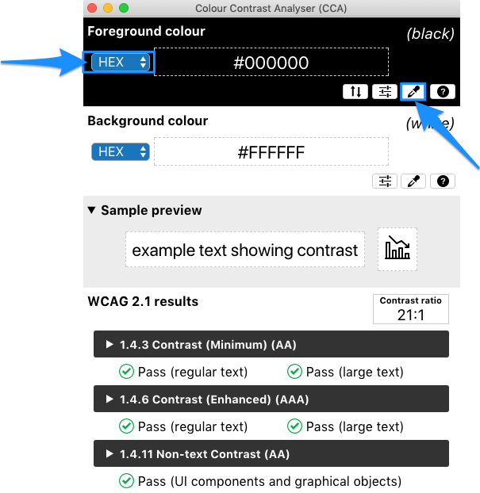
- Point the color picker ring at the foreground color (in most cases is the text) and then click.
The color picker ring will pick up the hex color code and show it in the CCA window.
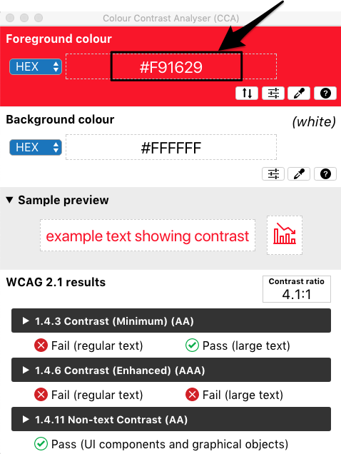
- Next, at the background color section, make sure that the “Hex” color code is selected, then click on a color picker icon.
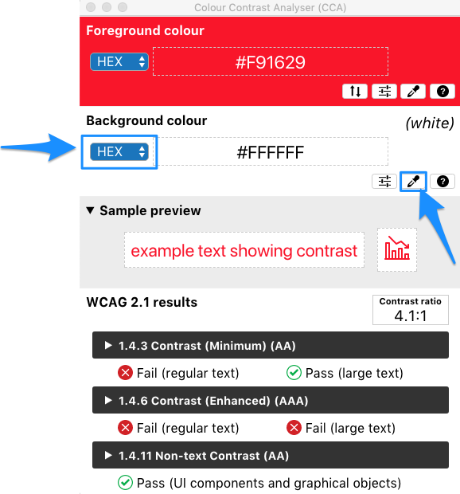
- Point the color picker ring at the background color of your document (in most cases is a white background).
- The color picker ring will pick up the hex color code and show it in the CCA window.
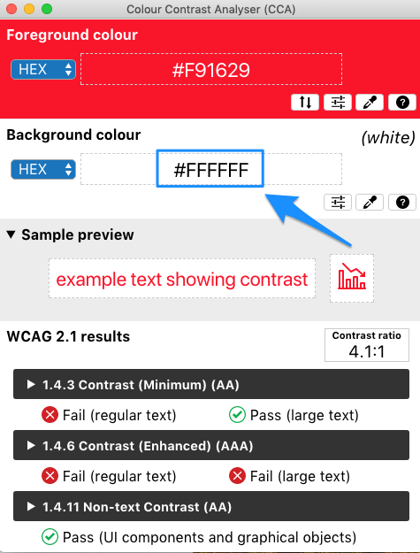
- CCA will calculate the contrast ratio between the foreground and background color based on WCAG 2.1. The result will show up. To get more details on the results, click the arrow to expand.
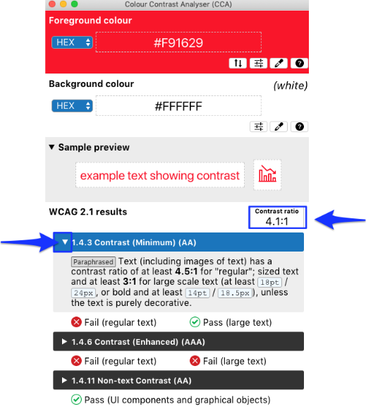
Note: The minimum contrast ratio should be 4.5: 1. If the contrast ratio of your content falls below the standard, consider to change the foreground color (text color) and reevaluate with the CCA again.

Sheet Tab(s)
Screen reader read sheet names, which provide information about what is found on the worksheet, making it easier to understand the contents of a workbook and to navigate through it.

How to rename the sheet tab to make sure that your worksheet is accessible?

- Right-click a sheet tab and select “Rename”.
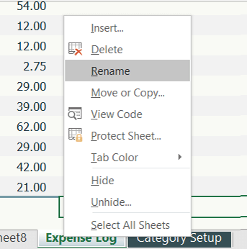
- Type a brief, unique name for the sheet and press “Enter”.
NOTE: To delete a sheet tab, right-click on the sheet tab you would live to remove and select “Delete”. This is if you are using multiple worksheets.

ACCESSIBILITY CHECKER
One of the best practices in checking whether your document is accessible is to run the Accessibility Checker. We are highly recommended that you run the checker once you have finished compiling your document.

How to check whether your Excel Spreadsheet accessible?

- Click on “Review” tab.
- Click on “Check Accessibility”
- The Accessibility dialog box will show up with the inspection results on the right pane.

If your document has accessibility issue, the inspection results will show “Errors”
Click on “Error” to expand and see the result in detail.

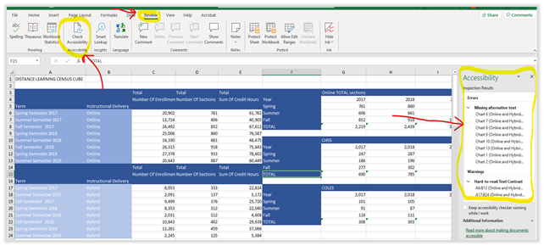

If your document has no accessibility issue, the inspection results will show appears as below.

