Creating an Accessible Microsoft Word Document

Table of Contents
CONTENT STRUCTURE 3
HYPERLINK 4
IMAGE 6
DATA TABLES 7
COLOR CONTRAST 8
Meta Data 12
ACCESSIBILITY CHECKER 14
CONVERT ACCESSIBLE MS WORD DOC TO ACCESSIBLE PDF 15

Creating an Accessible Microsoft Word Document
Below is the important aspects that you need to follow in order to make your Word Doc accessible to all users as well as complies with section 508.

- Structured Content
- Hyperlink
- Image
- Data Table
- Color contrast
- Meta Data
- Accessibility checker
- (optional) Converting accessible Word Doc to accessible PDF

CONTENT STRUCTURE
Providing a structured content will make it easy for users as well as the assistive technology to navigate your content. In order to make a structured content, you will need to apply heading styles to where it is appropriate.
How to make accessible content in MS Word?
- Select the text that you would like to make a heading.
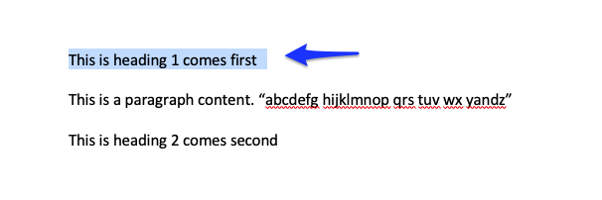
- Click on “Home” tab and select “Heading 1”.
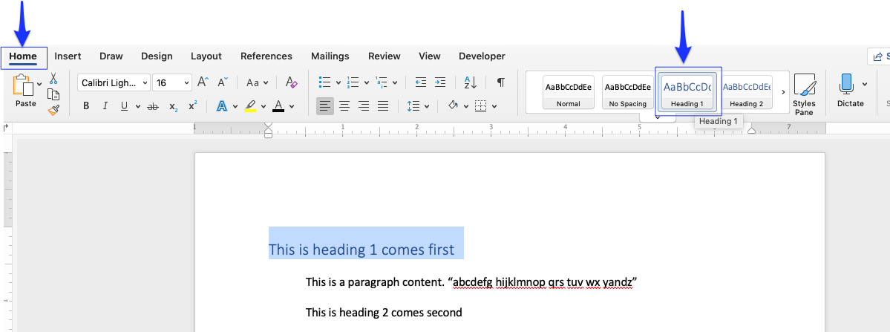

- Repeat the same method for heading 2, 3, 4,… where it is appropriate for your content.
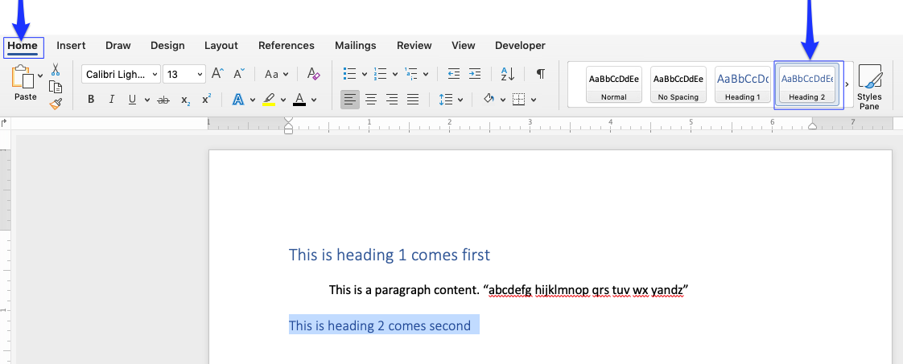

HYPERLINK
Hyperlinks are not always human-readable or screen-reader friendly. It is better to use human-readable text instead of lengthy or unreadable hyperlinks.
How to make hyperlink accessible in MS Word?

If you are a Mac user, follow the steps below.
- Select the hyperlink.
- Right click on the hyper link and select “Hyperlink”.
- Then, select “Edit Hyperlink”.
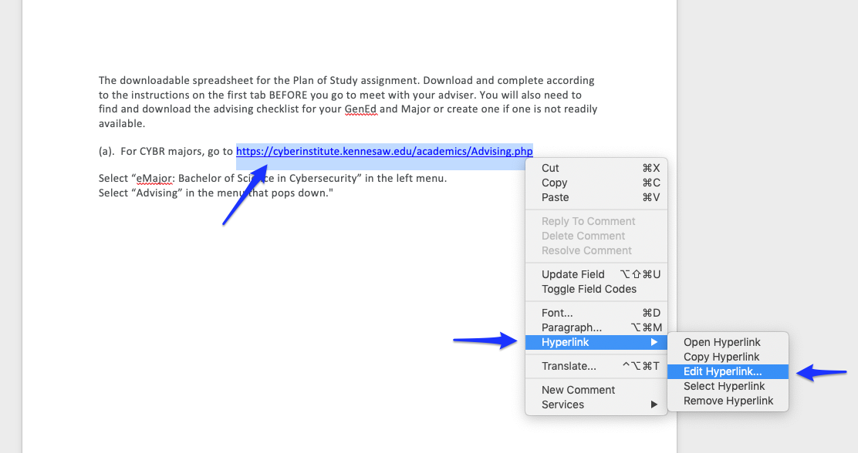

- Once the hyperlink dialog appears, delete the URL at the “Text to Display” box and type the descriptive text and then hit “OK”.
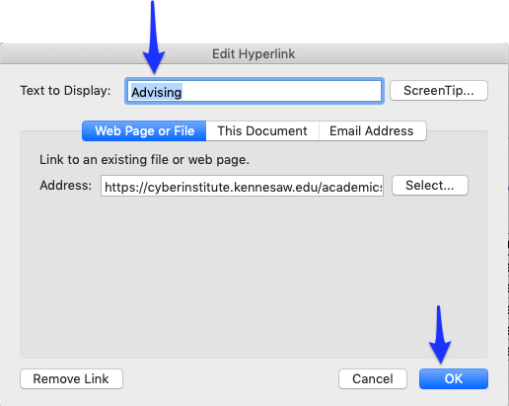

If you are a Windows user, follow the steps below.
- Select the hyperlink.
- Right click and select “Copy Hyperlink.”
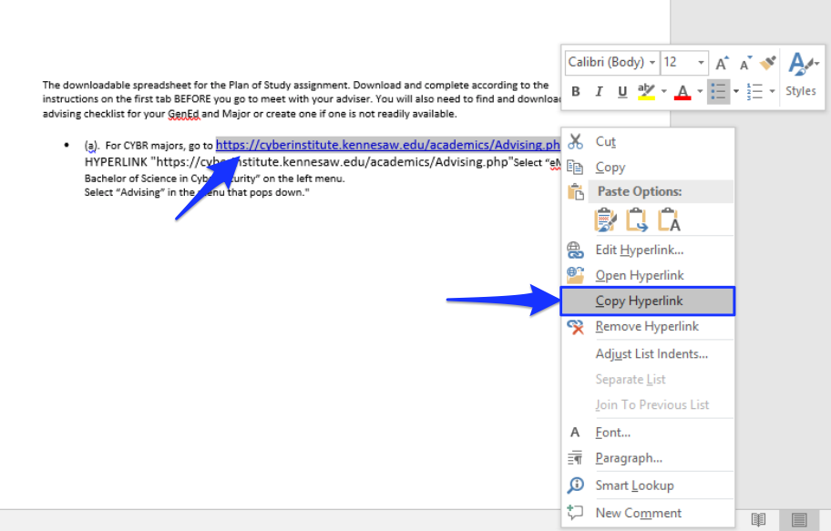
- Click on “Insert” tag, then click on “Link”

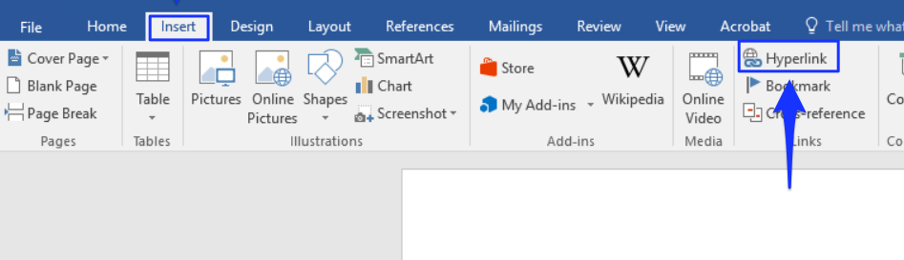

- The Edit Hyperlink dialog box will show up with the URL at Address and Text to display. Delete the URL at the Text to display, and type in descriptive text there. After that, hit “OK.”
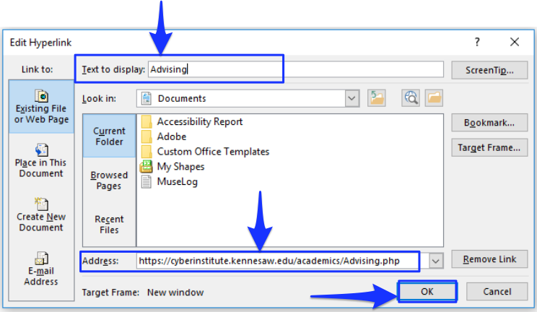

IMAGE
Alternative text (alt text) provides screen reader software users with access to all the non-text information.
How to make an image accessible in the MS Word?
- Click on the image.
- Right click and select “Edit Alt Text”.
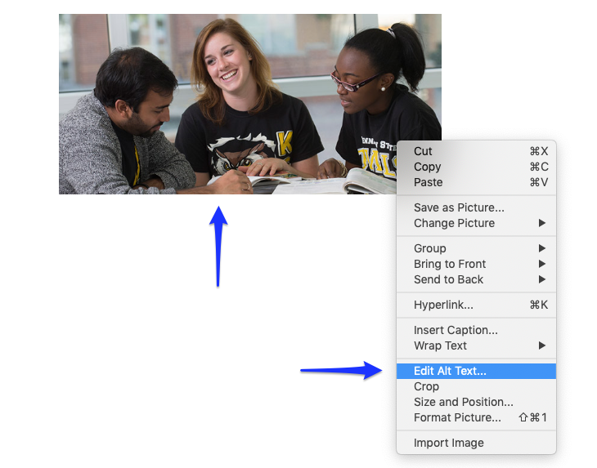

- The “Alt Text” dialog box will show up on the right pane. Type in the description of the image into the given box, or if you would like, you can click “Generate a description for me” to automatically generate the description.

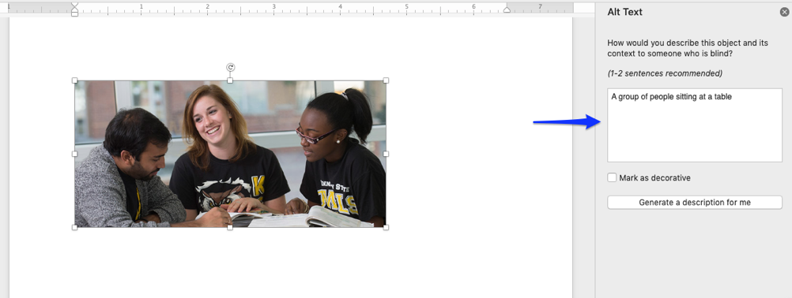

*Note: If you use the automatically generate the description option, please make sure the description matches with the image. Please also delete the phase “Description automatically generated”.
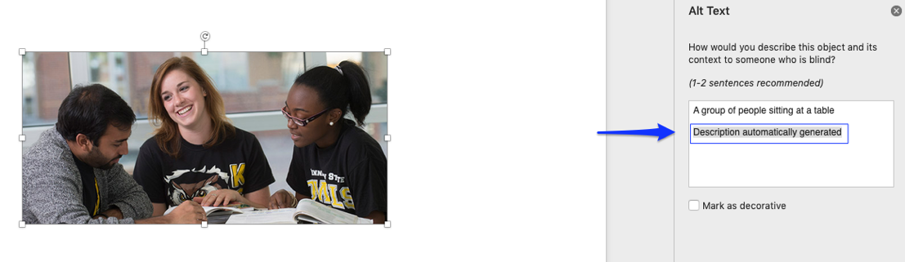

DATA TABLES
Accessible data tables help screen-reader users understand the relationships between table headers and the cells within their scope.
How to make accessible data tables in the MS Word?

Case 1: Simple Data Table with Row Header.
- Select the table header.
- Right click and select “Table Properties”
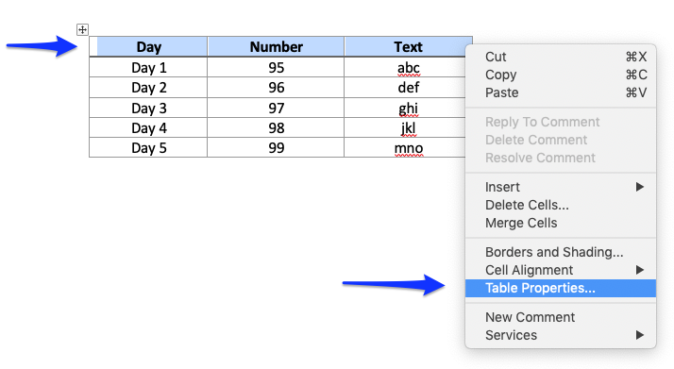

- The table properties dialog box will show up, then click on “Row” tab.
- CHECK the “Repeat as header row at the top of each page”. Make sure that “Allow row to break across pages” is UNCHECKED.
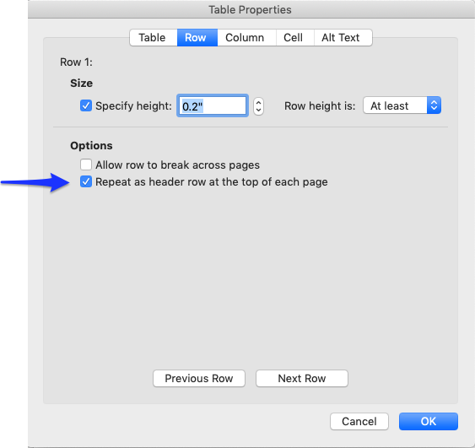
- Next, click on “Alt Text” tab, and type in the table title and description in the given boxes. Then, hit “OK”.
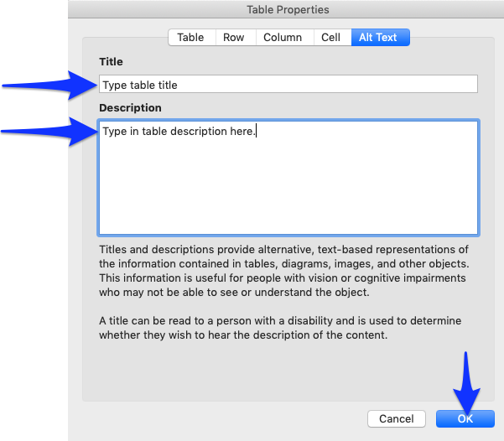

COLOR CONTRAST
Color contrast is crucial for users with visual disabilities. To make content accessible for them, content creator needs to take the ratio of the foreground and the background color into consideration.
According to WACG 2.0, the standard ratio of the foreground and background color should be at least 4.5:1
How to make sure that the color contrast meets the minimum accessibility standard?
The easiest way to measure the color contrast ratio is to use the Colour Contrast Analyser (CCA). This CCA will calculate the contrast ratio for you as well as give you the WCAG 2.1 results.

- Go to Colour Contrast Analyser website and click on “Download for Windows/ macO.”
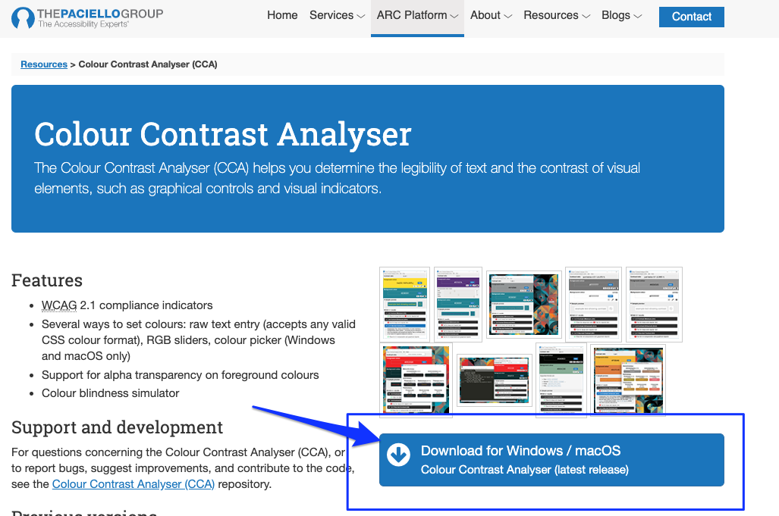
- Scroll down to the Assets section.
If you are a Mac user, click on “CCA-1.2.1.dmg” to download.
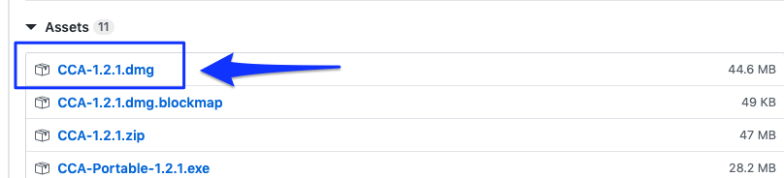
If you are a Windows user, click “CCA-Setup-1.2.1.exe” to download.
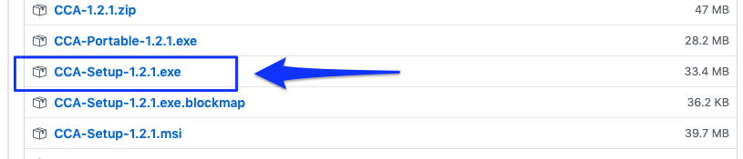
- Double click on the downloaded file and install it to your computer.
- Once you have installed it, the Colour Contrast Analyser (CCA) window will show up.
- Make sure that the “Hex” color code option is selected. Then, click on the color picker icon at the Foreground color section.
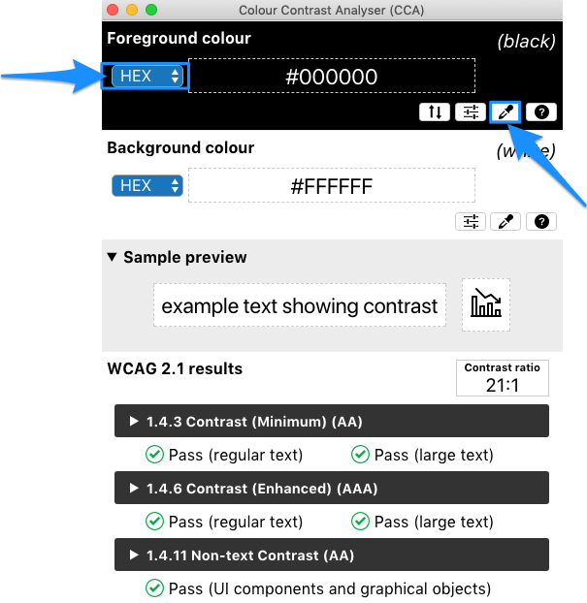
- Point the color picker ring at the foreground color (in most cases is the text) and then click.
The color picker ring will pick up the hex color code and show it in the CCA window.
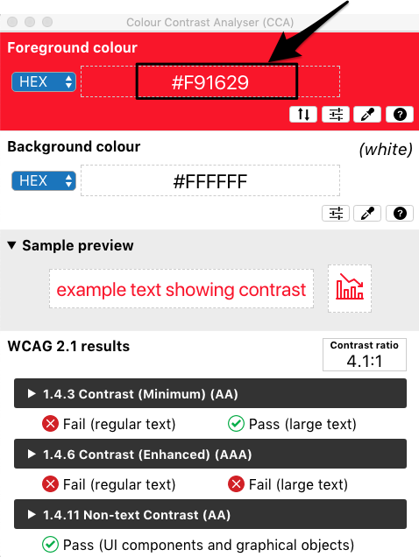

- Next, at the background color section, make sure that the “Hex” color code is selected, then click on a color picker icon.
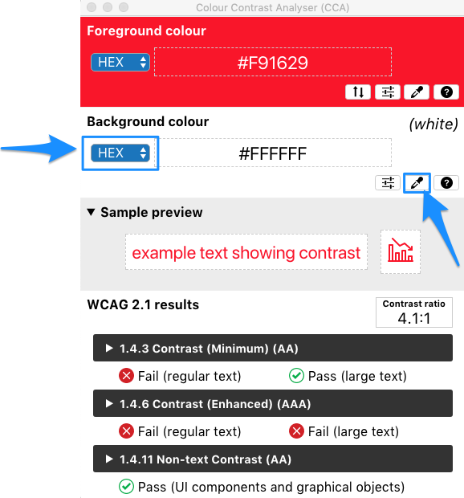
- Point the color picker ring at the background color of your document (in most cases is a white background).
- The color picker ring will pick up the hex color code and show it in the CCA window.
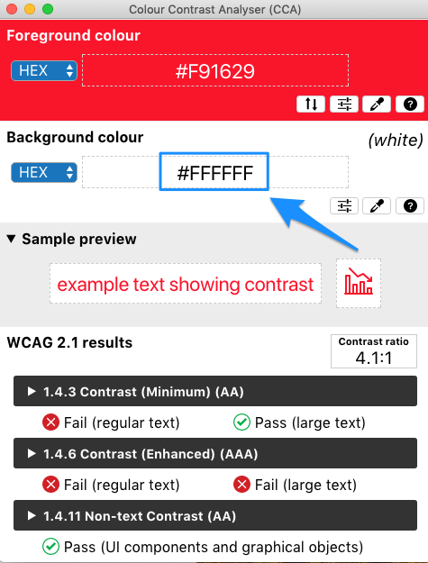
- CCA will calculate the contrast ratio between the foreground and background color based on WCAG 2.1. The result will show up. To get more details on the results, click the arrow to expand.
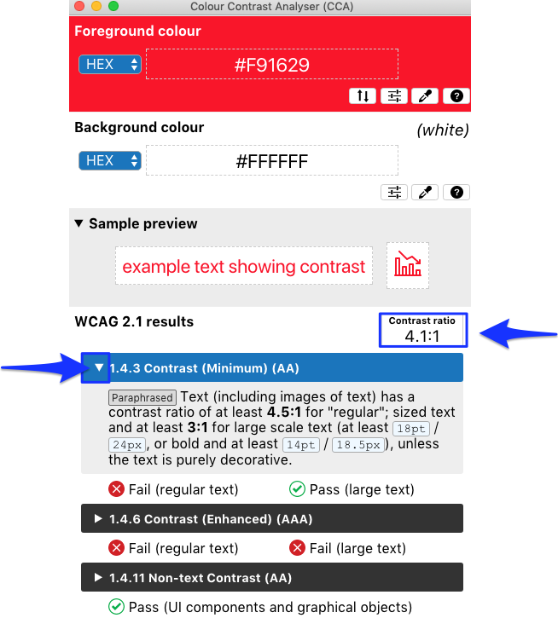
Note: The minimum contrast ratio should be 4.5: 1. If the contrast ratio of your content falls below the standard, consider to change the foreground color (text color) and reevaluate with the CCA again.

Meta Data
Meta Data refers to searchable fields within the document’s properties that identify what the document is about. It is an important element that you need to include especially when you aim to convert your Word Doc to a PDF. If your original Word Doc does not have Meta Data, you will have accessibility issues when running the PDF Accessibility Checker. Therefore, we highly recommend that you include Meta Data in your original Word Doc.
How to add Meta Data in Word Doc?

If you are a Mac user, follow the steps below.
- Click on “File” tab. Then, select “Properties”.
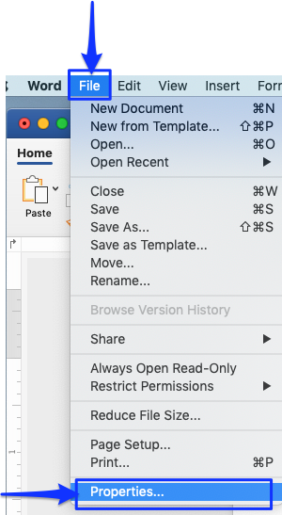

- The properties dialog box will appear, click on the “Summary” tab.
- Type in the “Title” and “Author” and the click “OK”

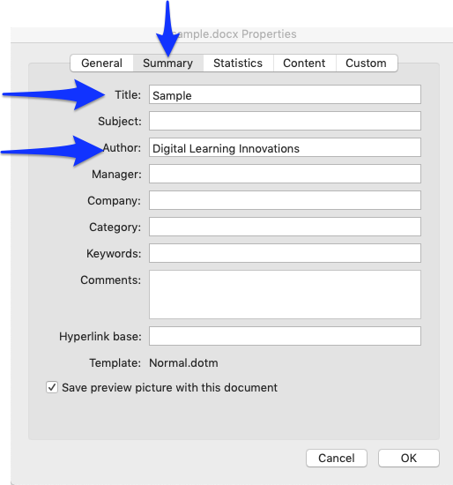

If you are a Windows user, follow the steps below.
- Click on File > Info > Properties > Advanced Properties.
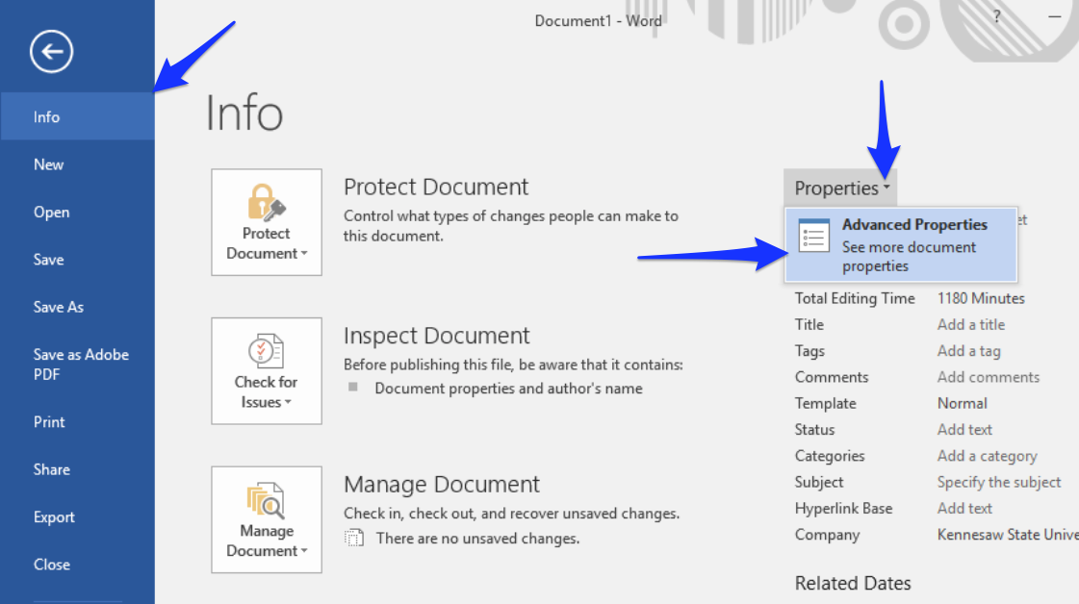

- The properties dialog box will appear, click on the “Summary” tab.
- Type in the “Title” and “Author” and the click “OK.”
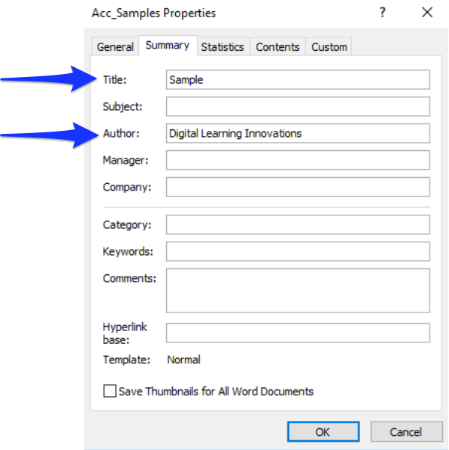

ACCESSIBILITY CHECKER
One of the best practices in checking whether your document is accessible is to run the Accessibility Checker. It is highly recommended that you run the checker once you have finished compiling your document.
How to check whether your Word Doc accessible?
- Click on “Review” tab.
- Click on “Check Accessibility.”
- The Accessibility dialog box will show up with the inspection results on the right pane.
If your document has accessibility issue, the inspection result will show “Errors.”
Click on “Error” to expand and see the result in detail.

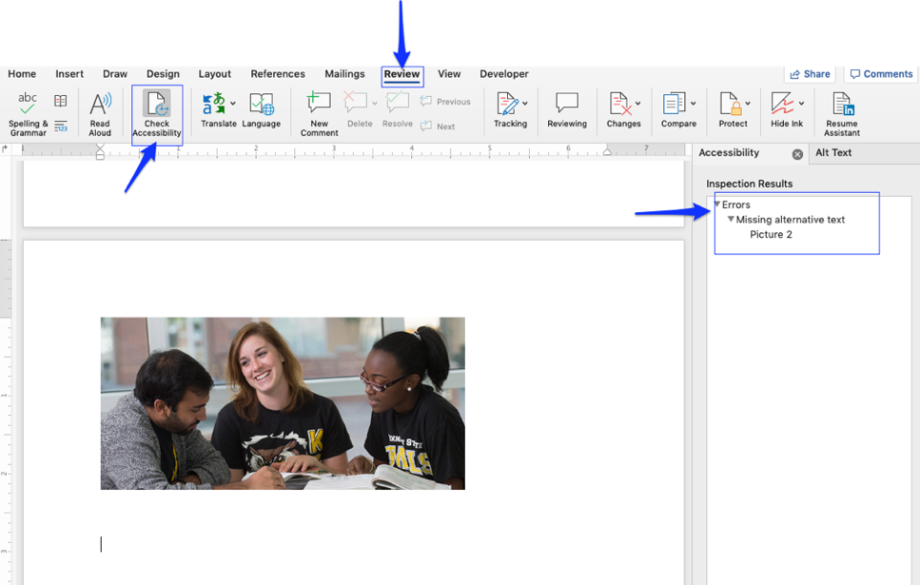

If your document has no accessibility issue, the inspection results will appear as below.

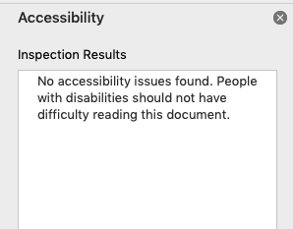

CONVERT ACCESSIBLE MS WORD DOC TO ACCESSIBLE PDF
It is a little tricky to convert accessible Word Doc to PDF. If you miss one selection in the converting process, your PDF will not pass PDF Accessibility Checker.
How to properly convert accessible Word Doc to accessible PDF?

If you are a Mac user, follow the steps below.
- Click on “File” tab. Then, select “Save As”.
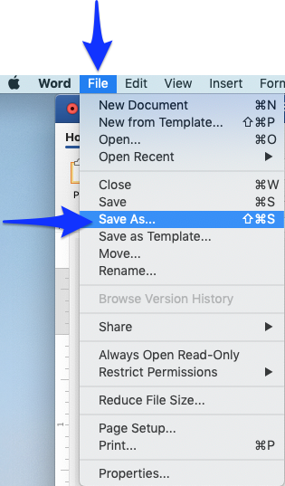

- At File Format, select “PDF”.
- This is very important, make sure that “Best for electronic distribution and accessibility (use Microsoft online service)” is selected. Then, hit “Export”

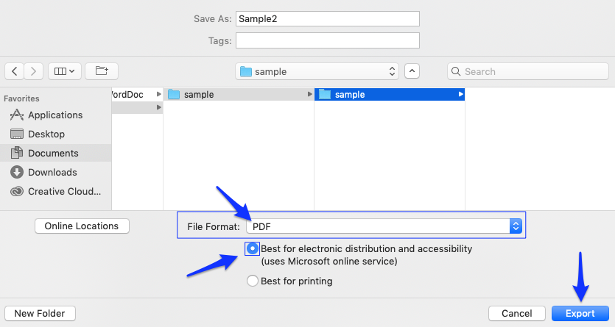

If you are a Windows user, follow the steps below.
- Click on File > Save As, and then select the storage for your PDF file.
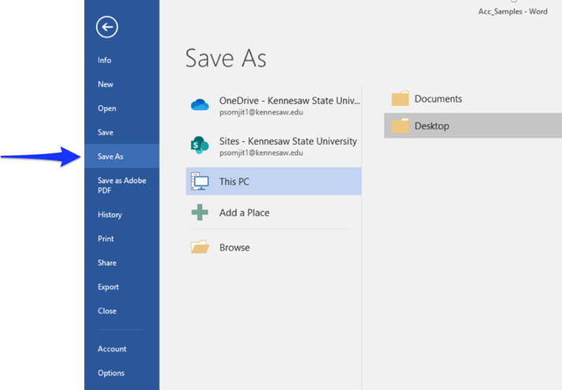
- The Save As dialog box will show up. A the Save as type: drop down menu, select “PDF”. Then click “Options..”
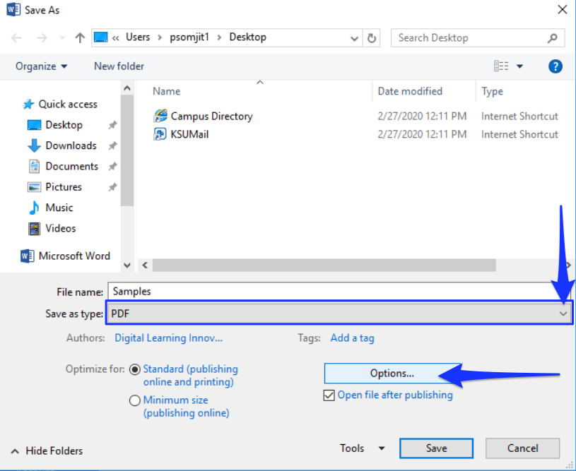
- The “Options” dialog box will show up, make sure that the “Document structure tags for accessibility” is checked, and then hit “OK.”
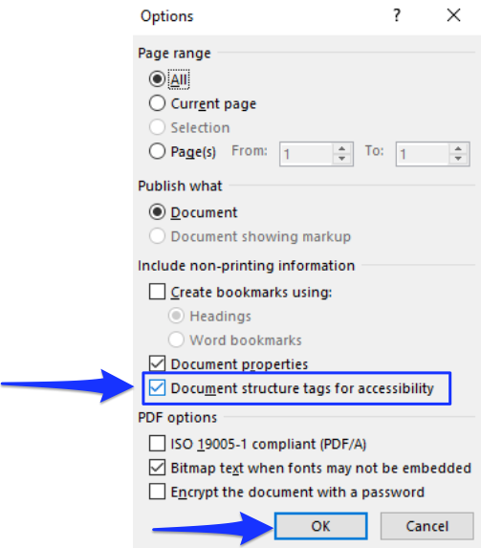
- You will be bounded back to the “Save As” dialog box, then hit “Save”
