Creating an Accessible D2L Course Content

Table of Contents
CONTENT STRUCTURE 2
HYPERLINK 3
IMAGE 4
DATA TABLE 6
COLOR CONTRAST 8
ACCESSIBILITY CHECKER 12

CONTENT STRUCTURE
Providing a structured content will make it easy for users as well as the assistive technology to navigate your content. In order to make a structured content, you will need to apply heading styles to where it is appropriate.
How to make structured content in D2L?
- Select the text that you would like to make a heading.
- At the Format option, select “H1 – Heading 1”

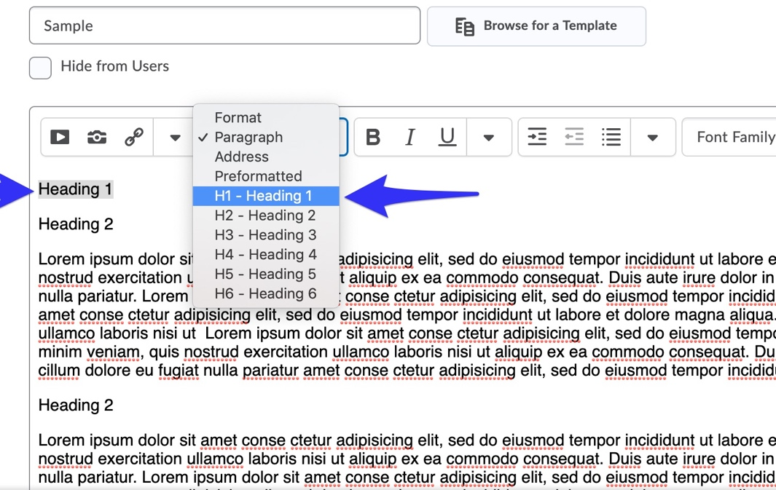

- Repeat the same method for heading 2, 3, 4,… where it is appropriate for your content.

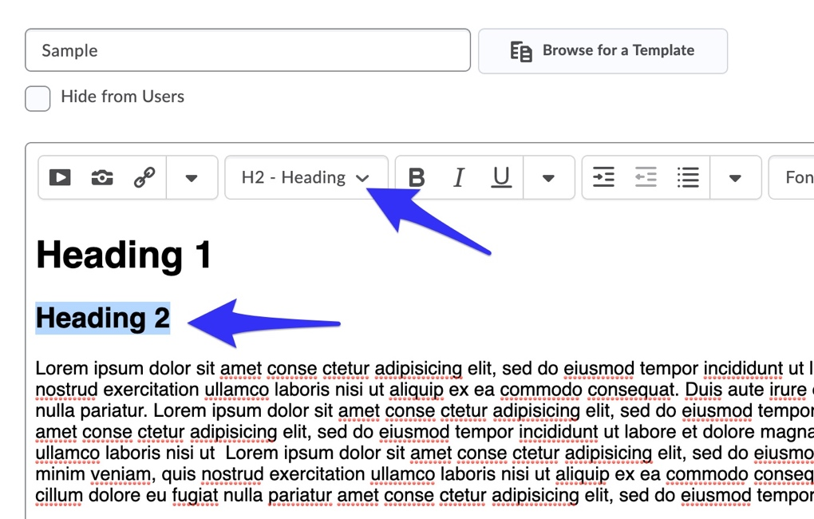

HYPERLINK
Hyperlinks are not always human-readable or screen-reader friendly. It is better to use human-readable text instead of lengthy or unreadable hyperlinks.
How to make hyperlink accessible in D2L?
- Select the hyperlink.
- Click on “Insert Quicklink” icon.
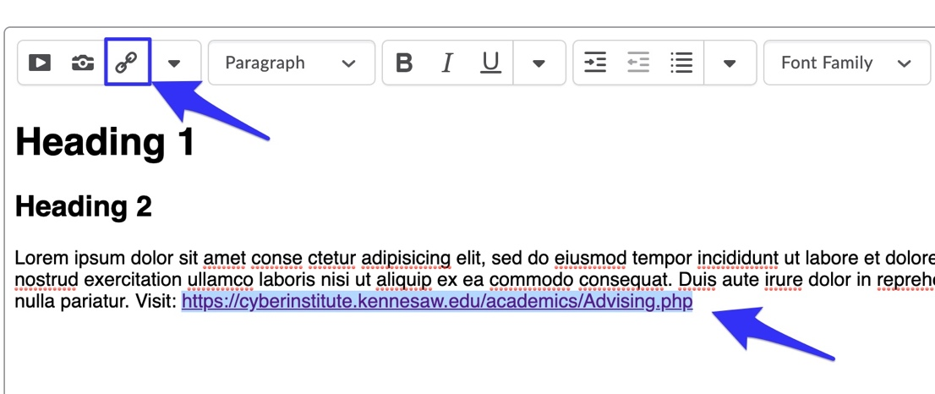

- An Insert Quicklink dialog box will show up, then type the descriptive text in “Title” box and click “Update”
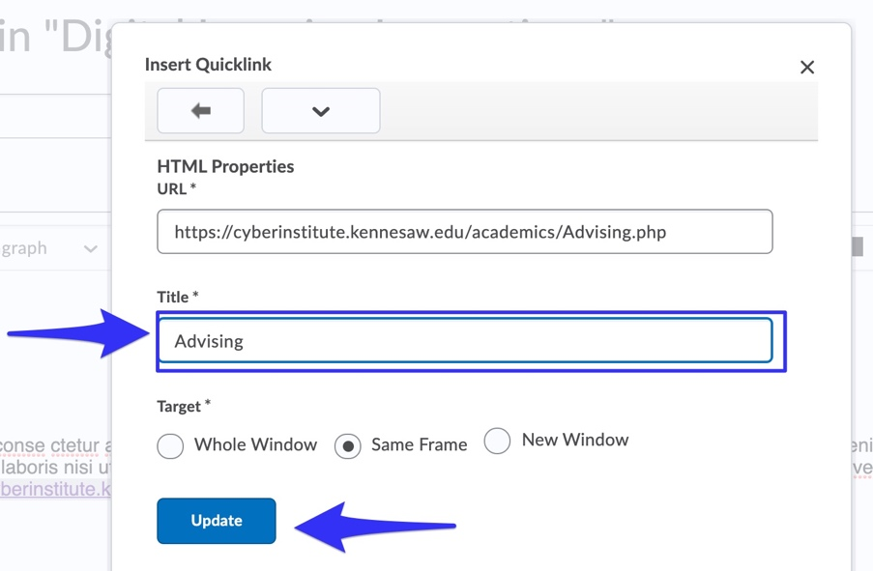

IMAGE
Alternative text (alt text) provides screen reader software users with access to all the non-text information.
How to make an image accessible in D2L course content?
- Click on Insert Image icon

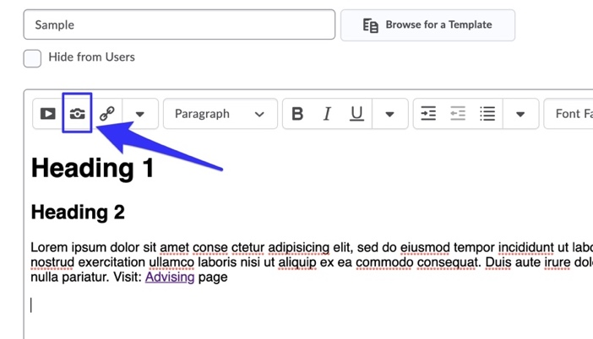

- The Insert Image dialog box will show up. Then, locate your image file and click “Add.”

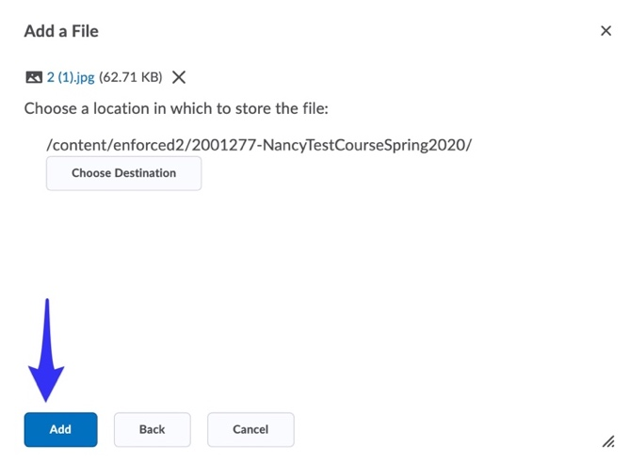

- The Alternative Text dialog box will appear. Type in the description of the image into the given box. If the image is purely decorative, does not add any new information, or already described adequately in the text, you can check the box called “This image is decorative.” After you’ve done one of these, click “OK.”

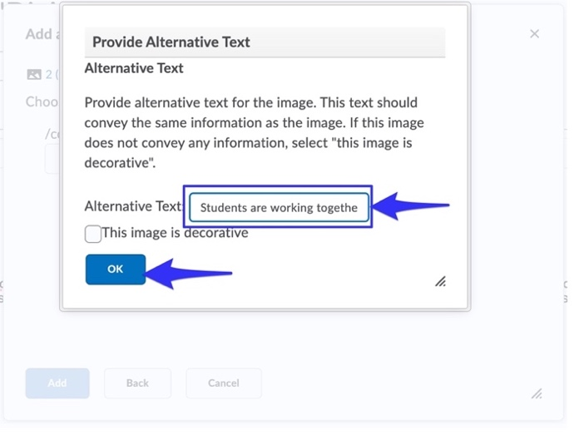

DATA TABLE
Accessible data tables help screen-reader users understand the relationships between table headers and the cells within their scope.
How to make accessible data tables in the D2L course content?
- Select the header
- Click on a dropdown menu next to the table icon.
- Then, select “Cell Properties.”

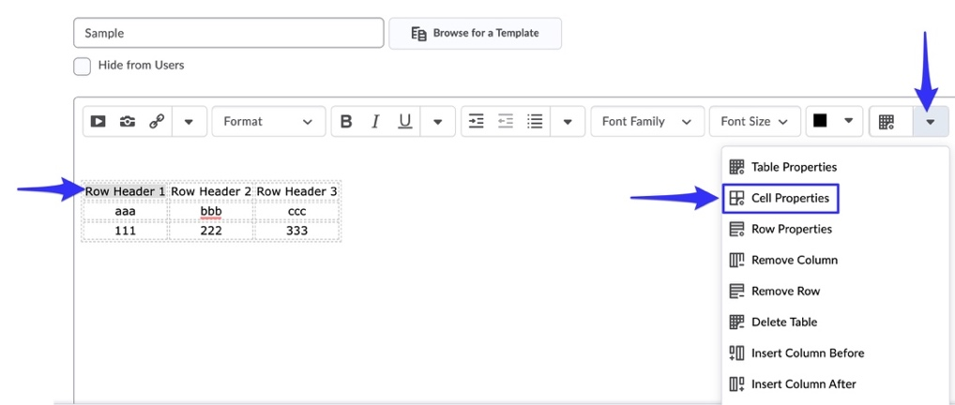
- The Cell Properties dialog box will show up, scroll down to the Cell Type option and select “Row Header” from the dropdown menu. And then hit “Update.”

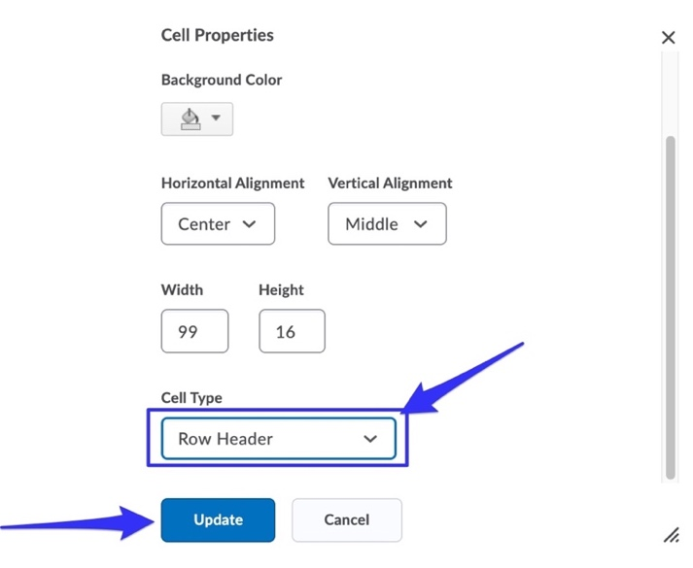

- Repeat step 1-4 for all row header cells.

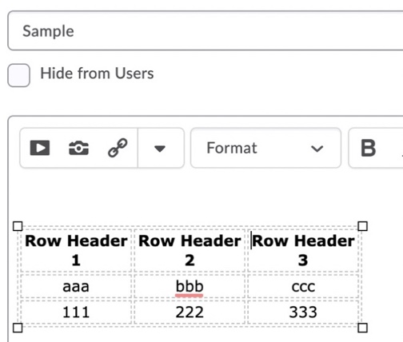

- Next, click table properties.
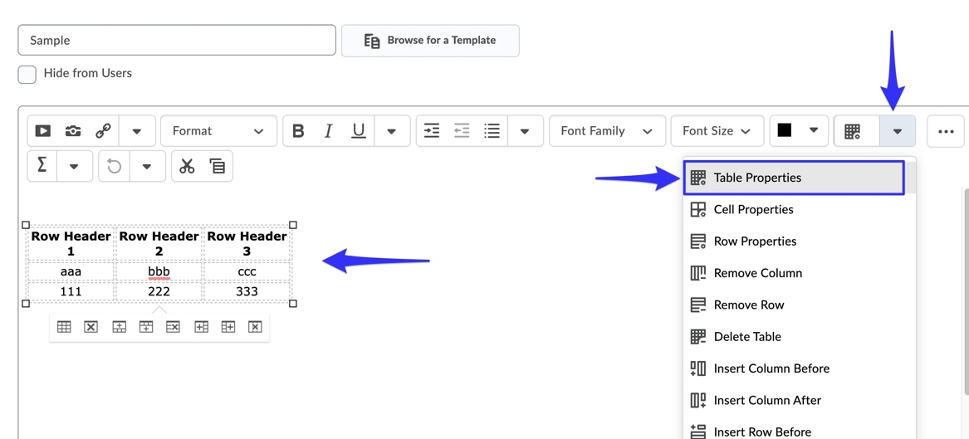
- Scroll down to “Include Caption”, then check the box and hit “Update.”
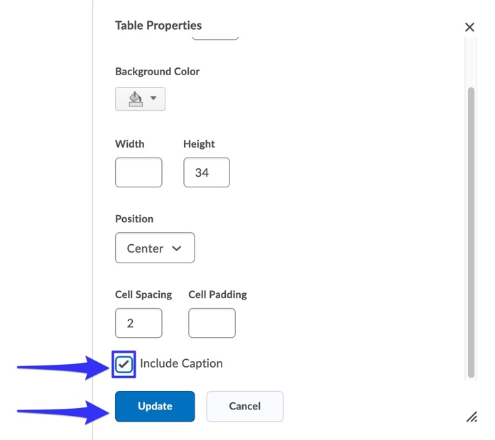
- Once you click update, the Caption Box will appear above the table. Type in the table caption.
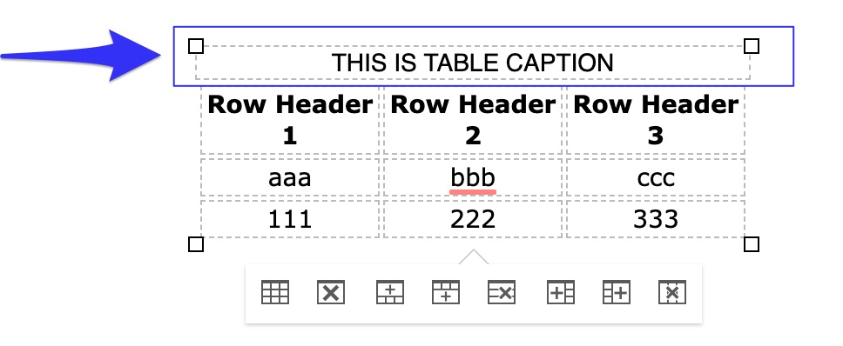

COLOR CONTRAST
Color contrast is crucial for users with visual disabilities. To make content accessible for them, content creator needs to take the ratio of the foreground and the background color into consideration.
According to WACG 2.0, the standard ratio of the foreground and background color should be at least 4.5:1
How to make sure that the color contrast meets the minimum accessibility standard?
The easiest way to measure the color contrast ratio is to use the Colour Contrast Analyser (CCA). This CCA will calculate the contrast ratio for you as well as give you the WCAG 2.1 results.

- Go to Colour Contrast Analyser website and click on “Download for Windows/ macO.”
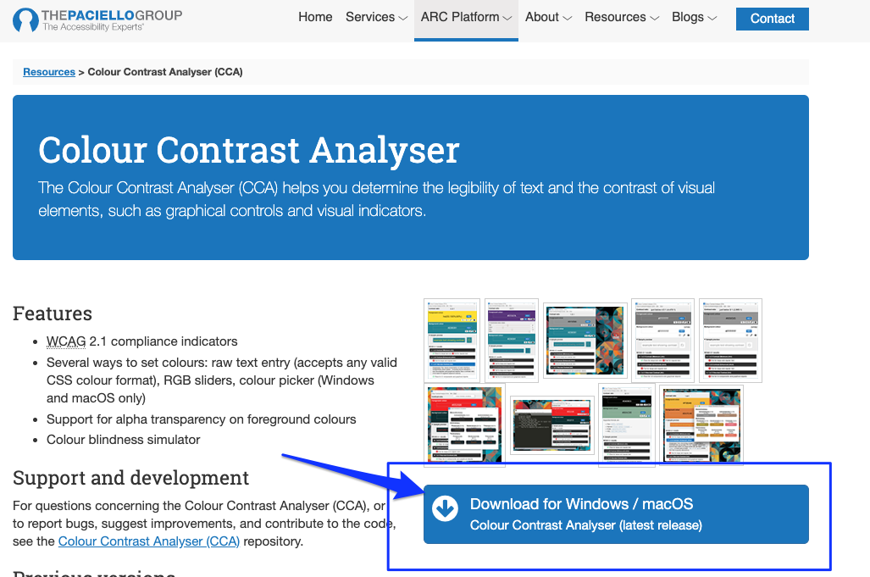
- Scroll down to the Assets section.
If you are a Mac user, click on “CCA-1.2.1.dmg” to download.
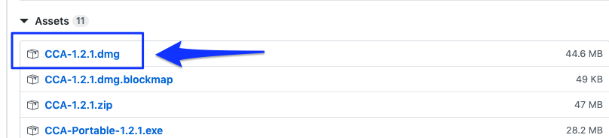
If you are a Windows user, click “CCA-Setup-1.2.1.exe” to download.
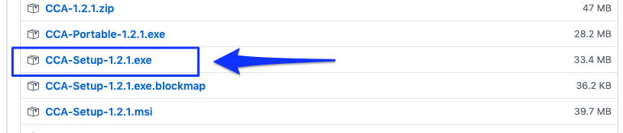
- Double click on the downloaded file and install it to your computer.
- Once you have installed it, the Colour Contrast Analyser (CCA) window will show up.
- Make sure that the “Hex” color code option is selected. Then, click on the color picker icon at the Foreground color section.
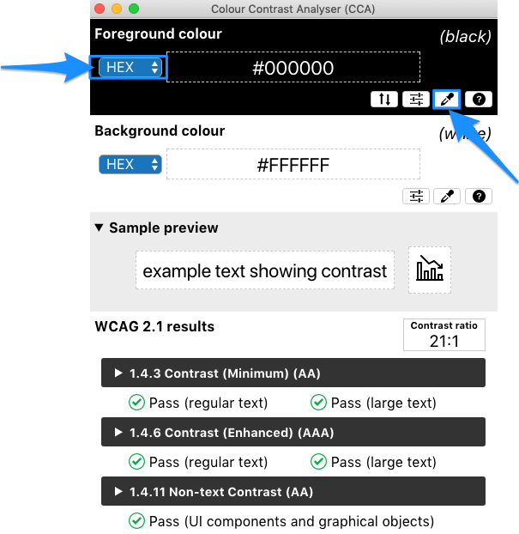
- Point the color picker ring at the foreground color (in most cases is the text) and then click.
The color picker ring will pick up the hex color code and show it in the CCA window.
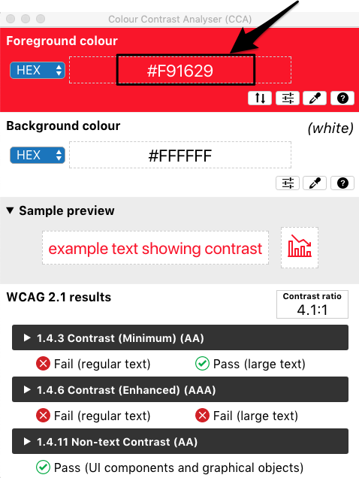

- Next, at the background color section, make sure that the “Hex” color code is selected, then click on a color picker icon.
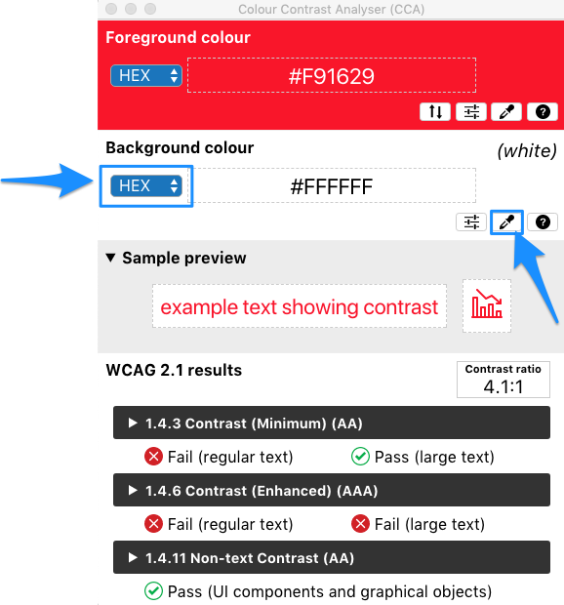
- Point the color picker ring at the background color of your document (in most cases is a white background).
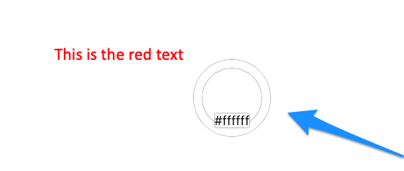
- The color picker ring will pick up the hex color code and show it in the CCA window.
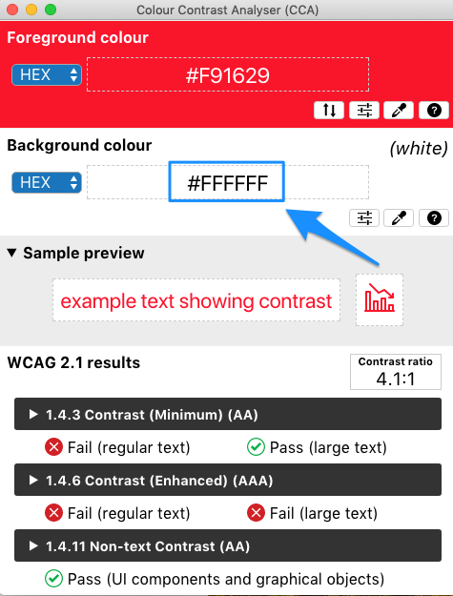
- CCA will calculate the contrast ratio between the foreground and background color based on WCAG 2.1. The result will show up. To get more details on the results, click the arrow to expand.
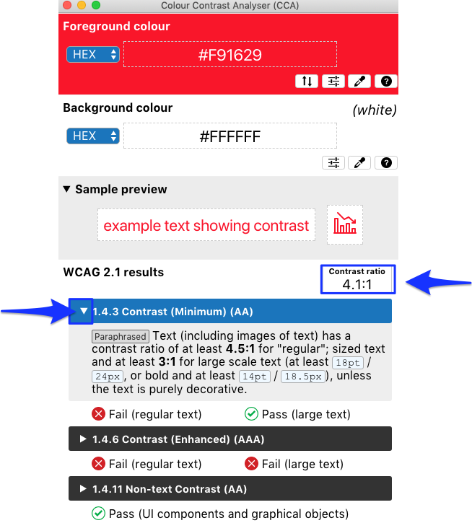
*Note: The minimum contrast ratio should be 4.5: 1. If the contrast ratio of your content falls below the standard, consider changing the foreground color (text color) and reevaluate with the CCA again.

ACCESSIBILITY CHECKER
One of the best practices in checking whether your D2L course content is accessible is to run the ACCESSIBILITY CHECKER.
How to check whether your D2L course content is accessible?
- Click at the Accessibility Checker icon located in the HTML toolbar. It looks like an “eye” with a checkmark next to it.
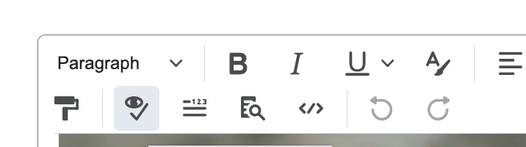

Once you have clicked it, the accessibility Checker will run the checker and show the result at the top right corner.
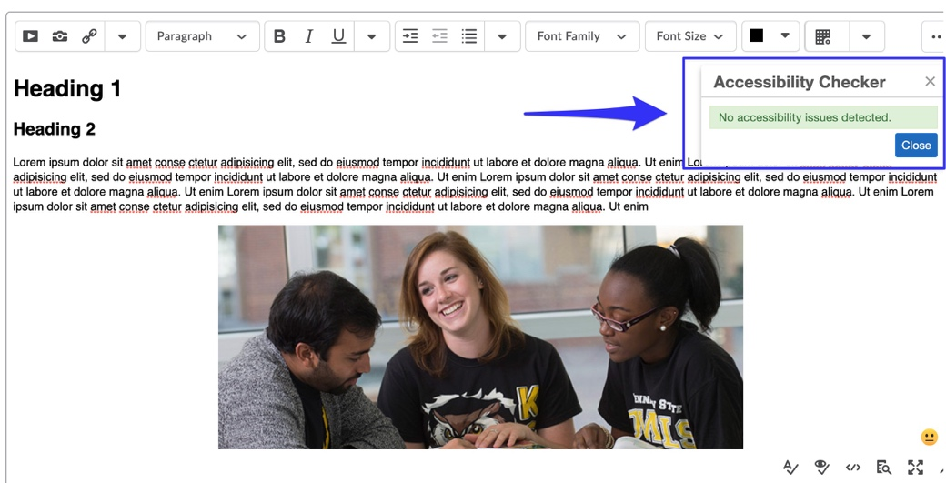
IMPORTANT: If there is an issue with accessibility, it will show the result and ask whether you would like to ignore or fix or go to the next issue.
