How to Enable HTML in a D2L Quiz
If you’re not sure how to enable HTML in a D2L Quiz, instructions are provided by Digital Learning Innovations (DLI) below. Please feel free to contact DLI (dli@kennesaw.edu) if you would like to explore other options for test security or need help with any settings described here.

- Within the quiz you wish to edit, click the Add/Edit Questions button.
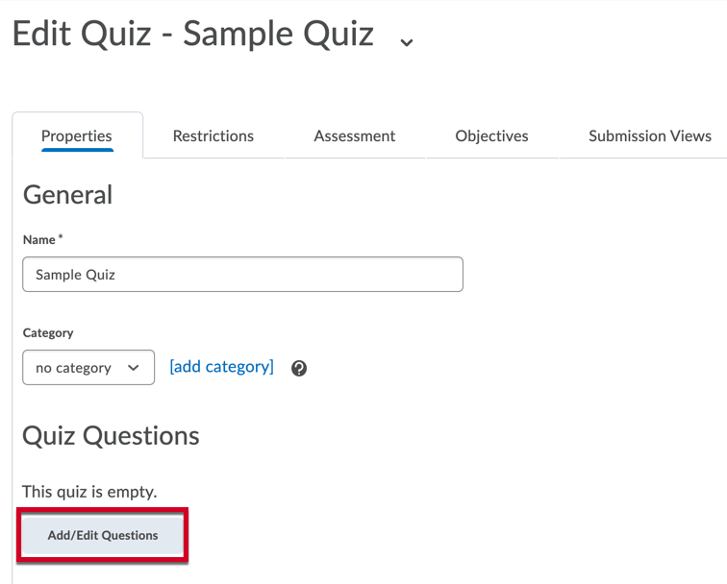
- Click the Add button.
- From the resulting dropdown menu, click New Question.
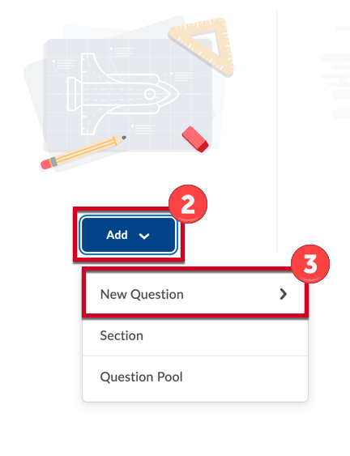

- From the resulting dropdown menu, select Written Response.
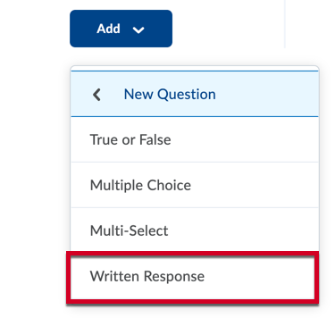
- Click checkbox to the left of the Enable HTML Editor for student responses option.
- Click the Save button.
