Validating Accessibility of the PDF File

ADOBE ACROBAT > ACCESSIBILITY CHECKER
One of the best practices in checking whether your PDF content is accessible is to run the ACCESSIBILITY CHECKER.
Note: In this tutorial, we will demonstrate how to run the Accessibility Checker in Adobe Acrobat DC.

How to check whether your PDF is accessible?
- Open your PDF file in Adobe Acrobat DC. Then, click on the right arrow to expand the right pane.
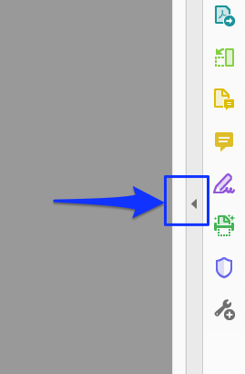
- Then, click on “More Tools.”

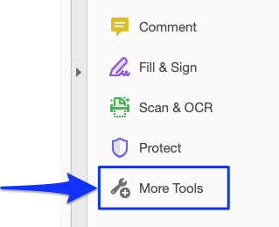

- All tools will appear. Scroll down to the “Protect & Standardize” section and click “Add” Accessibility.

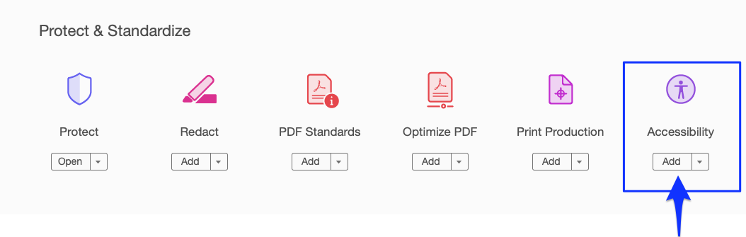

- Now, the Accessibility tool will show up on the right pane.
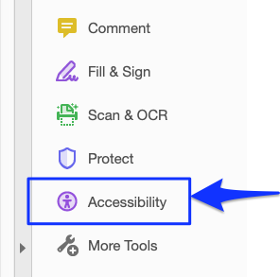
- Click on the “Accessibility” icon, the click “Full Check”

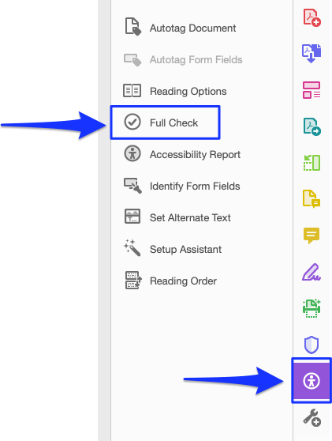

- The Accessibility Checker Options dialog box appears. Make sure that “Create accessibility report” option is checked. (We recommend that you create new folder to store the report. To do that, click “Choose” > “New folder”. Type in the folder name. Click “create” and then click “Choose”)

- Check all options, and make sure that category “Document” is selected. Then, click “Start Checking”
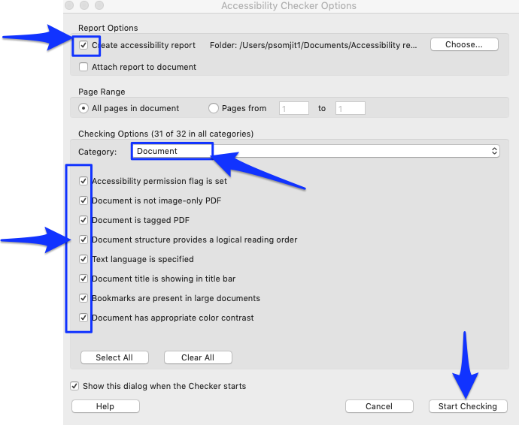

- The Accessibility checker report will show the results on the left pane.

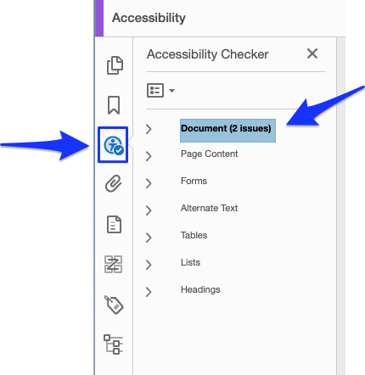

- Click the arrow to expand and check the issues.
Please note that these 2 issues: “Logical Reading Order” and “Color contrast” need manually check. (Though your PDF is accessible, you will still get these issues).

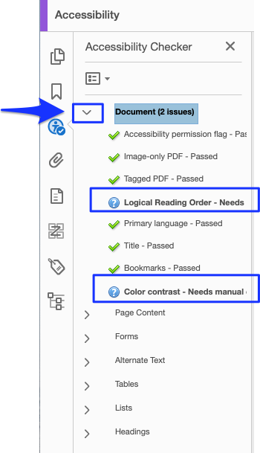
IMPORTANT: If you are getting other issues rather than “Logical Reading Order” and “Color Contrast”, we recommend that you go back to your source file (ex: Excel, Word, Indesign, etc.) and add necessary accessible components. Then, convert or save it as a new PDF and run the PDF Accessibility checker again.

